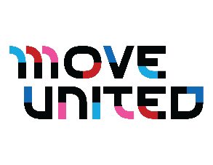
Thank you for your interest in the Move United Sanctioned Competitions! This resource is designed to help your organization easily share the upcoming adaptive sports opportunities for athletes of all ages and performance levels. Included below are four examples of ready-to-use content for social media, emails, newsletters, websites, and more.
If you need additional content, photos, or have any questions, don’t hesitate to reach out to us at marketing@moveunitedsport.org.
Let’s work together to spread the word about adaptive sports and empower more people to get involved!
Sample Content – Sanctioned Competitions 1
💪 PUSH WHAT’S POSSIBLE! Sports have the power to transform lives—bringing people together and breaking barriers. Move United Sanctioned Competitions are single and multi-sport events across the U.S., for adaptive athletes to thrive.
📍Find an event near you - https://moveunitedsport.org/events/sanctioned-competitions/sanctioned-competitions-calendar-2/
#AdaptiveSports #MoveUnited #Sports #Competition
Sample Content – Sanctioned Competitions 2
🏆 Move United Sanctioned Competitions are single and multi-sport events across the U.S. events for adaptive athletes to thrive. We’re committed to leaving no one on the sidelines.
Let’s push what’s possible—on and off the field! 🙌 https://moveunitedsport.org/events/sanctioned-competitions/sanctioned-competitions-calendar-2/
#AdaptiveSports #MoveUnited #Sports #Competition
Sample Content – The Hartford Nationals
🎉Headed to The Hartford Nationals! 🎉
I’m thrilled to share that I will be joining hundreds of incredible adaptive athletes from across the country to compete at The Hartford Nationals, conducted by Move United!
📍 Where: Grand Rapids, MI
📅 When: July 11–17, 2025
It’s a place where champions come together to compete and celebrate! 💪
I can’t wait to be part of this unforgettable experience. Let the countdown begin! ⏳
#TheHartfordNationals #MoveUnited #GrandRapids2025 #AdaptiveAthlete #ChampionsCompeteHere

