Finding Catalysts: Assessing and Building Organizational Capacity in Adaptive Sport

Resource Document

# Overview of workshop

The workshop was designed to achieve the following learning objectives:

1. Identify and evaluate current organizational capacities within adaptive sports.
2. Understand capacity building as a systematic, phased process.
3. Create and discuss actionable steps for developing an effective organizational capacity-building plan.

# Overview of resource document

This resource document summarizes key insights from the workshop on May 6 at the 2025 Move United Education event in Park City, Utah. It includes guiding questions to help your organization assess its current organizational capacity and reflect on enhancing existing capacities. This process prepares your organization to meet its needs and supports effective monitoring, evaluation, and sharing of outcomes, ultimately fostering growth and strengthening planning and infrastructure capacities. The resource document starts by summarizing key aspects of organizational capacity and capacity building, and it concludes with a set of guiding questions.

## About the guiding questions

The guiding questions are not absolute or all-inclusive. Each organization operates in a unique environment, and some questions may not apply. However, these questions serve as a guide to foster dialogue within the organization and with key stakeholders, encouraging reflection on its capacities and capacity-building efforts.

# Organizational capacity defined

Organizational capacity is a multidimensional concept that enables organizations to function effectively, modernize, and achieve their objectives (e.g., Andersson et al., 2016; Maleske & Sant, 2022; Wicker & Breuer, 2014). A widely used framework in sport management research is provided by Hall et al. (2003), which focuses on nonprofit organizations. This framework highlights that organizational capacity is influenced by environmental factors, access to resources, and historical context. It categorizes organizational capacity into three main areas: human, financial, and structural. The structural category is further divided into three subcategories. Definitions of these categories and subcategories are provided below.

1. **Financial capacity:** Capacity to develop and manage financial resources, including income, costs, assets, and debts.
2. **Human resource capacity:** The ability to utilize human capital (staff and volunteers) and their skills, knowledge, and motivation.
3. **Structural capacity:** Ability to utilize non-financial capital that persists after employees have left for the day.
   1. **Relationship Capacity:** Leveraging and maintaining relationships with clients, partners, volunteers, and government.
   2. **Infrastructure Capacity:** Utilizing and maintaining infrastructure (e.g., physical space), processes, and technology for operations.
   3. **Planning Capacity:** Developing and implementing strategic plans and policies.

# Capacity building defined

Capacity building involves solutions and processes that enhance an organization's effectiveness and efficiency in achieving its goals. It also helps organizations adapt to trends, promote social change, address deficiencies, and align programs and services with their strengths (e.g., Aragón, 2010; Misener & Doherty, 2013; Sobeck & Agius, 2007). Capacity building efforts can happen through internal means (e.g., hosting an organizational reach, hiring new staff) or through external means (e.g., training, mentorship, networking).

## Strategic capacity building model

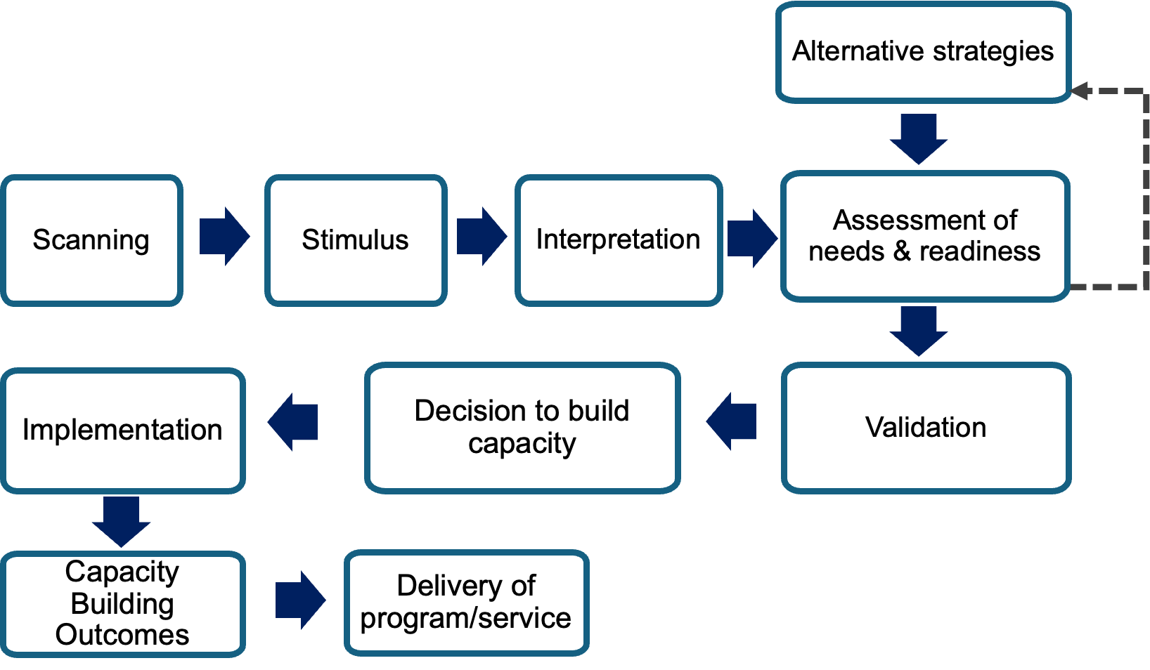

**Note.** The above capacity model was adapted from Millar & Doherty (2016)and expanded upon to include key elements highlighted in strategy development research (e.g., Narayanan & Fahey, 1982; Schneider, 1989).

# Understanding Baselines and Planning for Organizational Capacity Building

## Organizational capacity baseline questions

The following questions have been adapted from a research question guide developed by Hall et al. (2003) to assess the organizational capacity of non-profits, as well as from an interview guide utilized by Maleske and Sant (2022) to explore the role of development programs in enhancing the organizational capacities of national Paralympic committees.

### Financial capacity

1. Does your organization receive core funding? (*Definition: Core funding refers to the financial resources allocated to support the essential operations and activities of an organization.)*
   1. How does your organization secure its core funding?
2. Does your organization utilize project-based funding? *(Definition: Project-based funding designated for specific initiatives or programs, not day-to-day operations.)*
3. How does you organization secure project-based funding? Does it differ from your core funding?
4. What are the primary sources of your organization's financial resources?
5. In what ways does your organization's financing approach impact its ability to fulfill its mission?
6. What external factors influence your organization's financing activities and management?
7. What internal factors affect your organization's financing activities and management?
8. Considering your previous responses, what do you identify as your organization's greatest financial strength?
9. Based on your earlier answers, what do you see as your organization's most significant financial challenge?

### Human resource capacity

1. How many of the following does your organization have:
   1. Participants/athletes?
   2. Volunteers?
   3. Part-time staff?
   4. Full-time staff?
   5. Board members?
   6. Other individuals that do not fall into any of the above categories:
2. How does the above human resources affect your organization’s ability to achieve its objectives?
3. What external factors, outside of your organization, influence the availability and/or contribution of each human resource outlined above?
4. What internal factors, within your organization, influence the availability and/or contribution of each human resource outlined above?
5. Considering your previous responses, what do you identify as your organization's greatest human resource strength?
6. Based on your earlier answers, what do you see as your organization’s most significant human resource challenge?

### Structural capacity

#### Planning & Development

1. How satisfied are you with your organization’s ability to:
   1. Achieve its mission and objectives?
   2. Develop and make plans for the future?
2. What external factors, outside of your organization, influence its ability to plan and develop for the future?
3. What internal factors, within your organization, influence its ability to plan and develop for the future?
4. Considering your previous responses, what do you identify as your organization's greatest strength when it comes to planning and development?
5. Based on your earlier answers, what do you see as your organization’s most significant planning and developmental challenge?

#### Relationship capacity

1. Considering your organization’s current relationships, which do you believe are the most crucial for the following areas:
   1. Sustaining and/or enhancing your financial capacity?
   2. Sustaining and/or enhancing your human resource capacity?
   3. Sustaining and/or enhancing your planning and development capacity?
   4. Sustaining and/or enhancing your relationship capacity?
   5. Sustaining and/or enhancing your infrastructure, processes, and systems necessary for executing your organization’s day-to-day operations and programs/services?
2. Reflecting on your previous answers, are there any additional relationships that you believe are important for delivering programs, services, and/or fulfilling the organization’s mission?
3. What external factors, outside of your organization, influence its ability to sustain and/or enhance relationships?
4. What internal factors, within your organization, influence its ability to sustain and/or enhance relationships?
5. Based on your previous responses, what do you consider to be your organization's greatest strength in terms of its existing relationships?
6. Reflecting on your earlier responses, what do you identify as your organization’s most significant challenge related to relationships?

#### Infrastructure capacity

1. What physical spaces (e.g., office facilities, gyms) or equipment do you have access to for the following purposes:
   1. Carrying out your organization’s day-to-day operations?
   2. Implementing your organization’s programs and services?
2. What formalized processes and systems (e.g., internal/external communication, information technology, reporting) are in place to:
   1. Support your organization’s daily operations?
   2. Facilitate the implementation of your organization’s programs and services?
3. How satisfied are you with your organization’s current:
   1. Infrastructure (e.g., physical space, equipment)?
   2. Processes and systems (e.g., communication, information management)?
4. Reflecting on your previous responses, what do you consider to be your organization's greatest strength in terms of infrastructure, processes, and systems?
5. Based on your earlier answers, what do you perceive as your organization’s most significant challenges regarding infrastructure, processes, and systems?

## Capacity building questions

The following questions are based on the strategic capacity-building model previously outlined. They are designed to facilitate reflection on your organization’s past capacity-building initiatives and to highlight critical areas where strategic processes may fall short. It’s important to note that there is no one-size-fits-all approach to building organizational capacity; each organization is distinct in its mission, goals, capacities, programs, and services. Furthermore, the external environment in which an organization operates (e.g., community accessibility) can present challenges that impede capacity building. As a result, not all questions may be relevant to your specific situation. Depending on the circumstances prompting your organization to build capacity, you may find that time constraints limit your ability to reflect on every step. In particular, during crises or when confronted with significant threats, your organization may need to rapidly develop capacity—especially in terms of processes and systems—to effectively address the immediate challenges at hand***.***

### Scanning and interpretation of stimuli

1. How does your organization track and gather relevant information that supports its services, programs, and mission?
2. Is there a formalized process for collecting, sharing, and acting on this information among:
   1. relevant internal staff, volunteers, and leadership?
   2. external stakeholders (e.g., participants, donors)?
3. How does your organization determine the importance or relevance of the information it collects?
4. How promptly does your organization act on the information received?
5. Reflecting on past instances when your organization has enhanced its capacity and resources, what sources of information contributed to these enhancements?
   1. Were these sources internal or external?

### Assessment of needs, readiness, and alternative strategies

1. What organizational capacities are essential for maintaining your current programs and services?
2. Would building capacity (a) divert resources from or (b) hinder the execution of existing programs and services?
3. What capacities will the organization need to develop over the next five to ten years?
4. What are the key needs of your stakeholders? *(Tip: Consider reviewing your responses related to relationship capacity for insights.)*
5. Can your organization adjust its programming to align with current organizational capacities instead of building new capacity? If so, how?

### Validation and decision to build capacity

1. Which internal and external stakeholders should be considered or have a voice in determining:
   1. What the organization needs in terms of capacity?
   2. The approval or confirmation of plans to build capacity?
   3. What (if any) are the potential repercussions of not including a specific stakeholder in the assessment of the organization's needs and plans?
2. How does your organization confirm the need for and the plans to build capacity? Consider the following examples or ideas:
   1. Leadership judgment (e.g., Board or Executive Director)
   2. Established processes (e.g., internal procedures or processes set by another entity of which your organization is a member)
   3. Historical factors (i.e., based on previous decisions or outcomes of your organization or other adaptive sport programs)
   4. Negotiation/consensus (e.g., meetings with internal and external stakeholders)
   5. e. Other
3. Reflecting on past instances when your organization has enhanced its capacity and resources, what has been effective and ineffective in confirming the organization's needs and making decisions about building capacity and resources?
4. If the need for and plans to build capacity are confirmed and approved, can the organization articulate how these efforts align with and enhance its mission? *(Tip: If articulating this alignment proves challenging, it may indicate that additional information is required or that the capacity being built could potentially detract from the organization’s mission.)*

### Design and implementation of capacity building initiatives

1. What specific goals does the organization aim to achieve through capacity building initiative?
   1. What key performance indicators or supporting objectives can be established to effectively measure and ensure that capacity is being built?
2. Who will be responsible for:
   1. Planning the capacity building initiative?
   2. Implementing the capacity building initiative?
   3. Evaluating the capacity building initiative?
   4. Supervising the capacity building initiative?
   5. Consulting relevant stakeholders during the capacity building initiative?
   6. Reporting both positive and negative outcomes and impacts on programs and services resulting from the capacity-building initiative
   7. Sustaining the built capacity?
3. Will these individuals be with the organization long-term?

### Monitoring, evaluation, and learning

1. Who will monitor, evaluate, and report on the capacity building initiatives? *(Repeated from Step 5)*
2. How will these efforts be measured against the organizational capacity baselines?
3. How will the impacts on program or service delivery be assessed in the short-term and long-term?
4. How will outcomes and lessons learned be shared with key stakeholders?