Asked of a number of the below mentioned companies. None gave me any useful information.

I am presenting a clinic at this year's Ski Spectacular in Breckenridge Colorado titled ‘Modern Systems for Managing Student Intake and Participation Info’. It is geared towards ski school Managers. I would like to include your system. I would like a demo and pricing information.

Thank You
John

List of companies I found by searching for some version of Ski School Scheduling Software.

Vermont Systems
- vermontsystems.com – CEHRecreation.com
- Contacted for a demo.
- USA
- Dasha Russell <DashaR@CEHRecreation.com>
- Connecting me to Josh for a video demo.
- Pricing is based on concurrent users. Must estimate the greatest number of computers simultaneously linked to the system.
- They are geared for municipalities for parks and rec. They have lots of modules and it has to be specially configured for a ski school. Extensive reporting options.
- Promised some slides. Nothing delivered.
- They also claim that they are more targeted towards municipalities – parks and rec.
- No slides

snow-office.com
- Swiss
- contact to see if they operate in the us.
- Online demo
- Owned by TBM Group AG
- Filled out some info below. Generic with limited information for adaptive schools
- Slides below.
- Appers to be the same as skischoolssoftware.com
- about $3000 per year.

flaik
- flaik.com
- us offices
- requested demo
- Powdr uses them.
- Slides Below.

roverd
- roverd.com
- us offices
- seems more of a travel booking agency
- Does not apply to ski schools.
- No slides.

Waldhart
- https://www.waldhart.at/en/solutions/ski-school-software/
- Austria
- Has some videos and you can request a quote.
- comprehensive software solution that covers booking, scheduling, billing of ski instructors and statistical analyses. It also includes tools for customer loyalty.
- Cost no real answer. They say cost is customized to your needs
- Can be configured however you want it.
- Slides below.

Skischoolssoftware
- skischoolssoftware.com
- swiss
- appears to be the same as snow-office.com
- about $3000 per year.

Only Sky
- theonlysky.com
- denver colorado
- Contact Info Alex Wright <awright@theonlysky.com>, Charles Von Thun <charles@theonlysky.com>
- Mention Adaptive Lessons
- They do Ticketing and Rentals (rentals integrated with including another system)r. Also add on for Hotel room booking.
- The profiles and user interaction is fully customizable.
- They will help with creating forms but customer can do it on their own.
- Provide training to get system up and running
- They can process waivers.
- Calendar for assigning students to instructors.
- Demographics for most anything in the profile. Generates a table of information no graphic rendering of results.
- Instructors can send notes to students and a private note section that can be seen by future instructors. Progress reports seem somewhat limited in capabilities.
- There is an automated SMS and email option for sending notices and alerts.
- Setup fee and transaction fee. Transaction fee starts at 4.9% of each transaction and can drop based on volume.
- Awaiting some screen shots promised by Alex Wright <awright@theonlysky.com>
- Promised some slides. Nothing came.

Salesforce
- Vague statements like below.
- Organizations like U.S. Ski & Snowboard and Swiss-Ski use Salesforce to streamline forms, manage athlete information, and communicate with members through personalized campaigns and online portals.
- No demos.
- No Price information.
- Free to non-profits. However it’s a raw salesforce system. You need salesforce programmers (cost) to make it work.
- A salesforce rep indicated that he could not imagine any modules that would apply to adaptive schools. All custom work.

Accountsx
- xtcsoftware@gmail.com
- Targeted at adaptive ski schools.
- 27 years
- Rollinsville Colorado
- Automated emails and sms messaging.
- Controlled Account Setup.
- Allow equipment assignments to students.
- Financials and scholarships. Customized to your model.
- Paypal, Stripe, Custom credit card processing.
- $7000 to get started. Includes training and setup.
- $1000 subscription per year .
- No mobile app.
- References available.


xtcsoftware@gmail.com
Snow Buddy
- snowbuddy.app
- Romania
- Is not any scheduling software. Appears to be a dead end.

Yo planning
- https://www.yoplanning.com/en/industries/ski-school-software
- France
- requested demo.

Arboxapp
- arboxapp.com
- requested demo.
- Israel

bloowatch
- bloowatch.com
- Spain
- Will schedule a demo.

Team axess
- teamaxess.com
- A full blown system –for the entire resort. ticketing, access gates, rental, ….
- May look more into it.

Mates Snowsports Software
- snowsports-software.com
- Czech Republic
- Cannot access the demo form.

Peak Pro
- peakpro.com
- No ski school solution.

Civic Plus
- civicplus.com
- No ski school solution.

Supersass
- https://www.supersaas.com/info/sports-lessons-booking-system
- Not specifically geared towards ski schools.
- Free account I will give it a try.

Dash Platform
- dashplatform.com
- Not geared towards ski schools.

Accesso
- accesso.com
- geared towards ticket sales and marketing.
- England.

Singenuity
- singenuity.com
- Utah
- full blown ski resort solution.
- Demo available.

Intouch
- intouchelevate.com
- New Zealand
- Video to review.

Waldhart Software
- waldhart.at
- Austria
- Need to contact. Little information on system or pricing online.

Aspenware
- aspenware.com
- Denver Colorado
- asked for a demo.

These popup up when asking for ski instructor scheduling software. All geared towards individuals or small business.

Vev
- vev.co/specialty/private-ski-lessons
- All the regular scheduling items. Not specifically geared to adaptive or snowsports.
- $39.99 a month for 5 team members access.
- Customer list does not include ski schools.
- Netherlands

MindBodyOnline
- mindbodyonline.com
- All the regular scheduling items. Not specifically geared to adaptive or snowsports.
- Pricing will not say
- No ski schools on their customer list.
- Ultimately owned by US Bank.

Acuity scheduling
- acuityscheduling.com/
- All the regular scheduling items. Not specifically geared to adaptive or snowsports.
- $49 per month
- No ski schools on their customer list.
- Owned by Squarespace

Wpamelia
- wpamelia.com
- WordPress plugin for scheduling
- All the regular scheduling items. Not specifically geared to adaptive or snowsports.
- Reasonable option starts at $219 one time purchase.
- No ski schools on their customer list.

Coacha.
- https://www.coacha.co.uk/
- All the regular scheduling items. Not specifically geared to adaptive or snowsports.
- $27.50 per month reasonable starter
- No ski schools on their customer list.
- England

snow-office.com, skischoolssoftware.com

Different organizations/web sites but the same pages.

Uses stripe for transactions.
Starts at $2700 per year.
Free version which I evaluated was pretty useless.

Creating a new lesson type
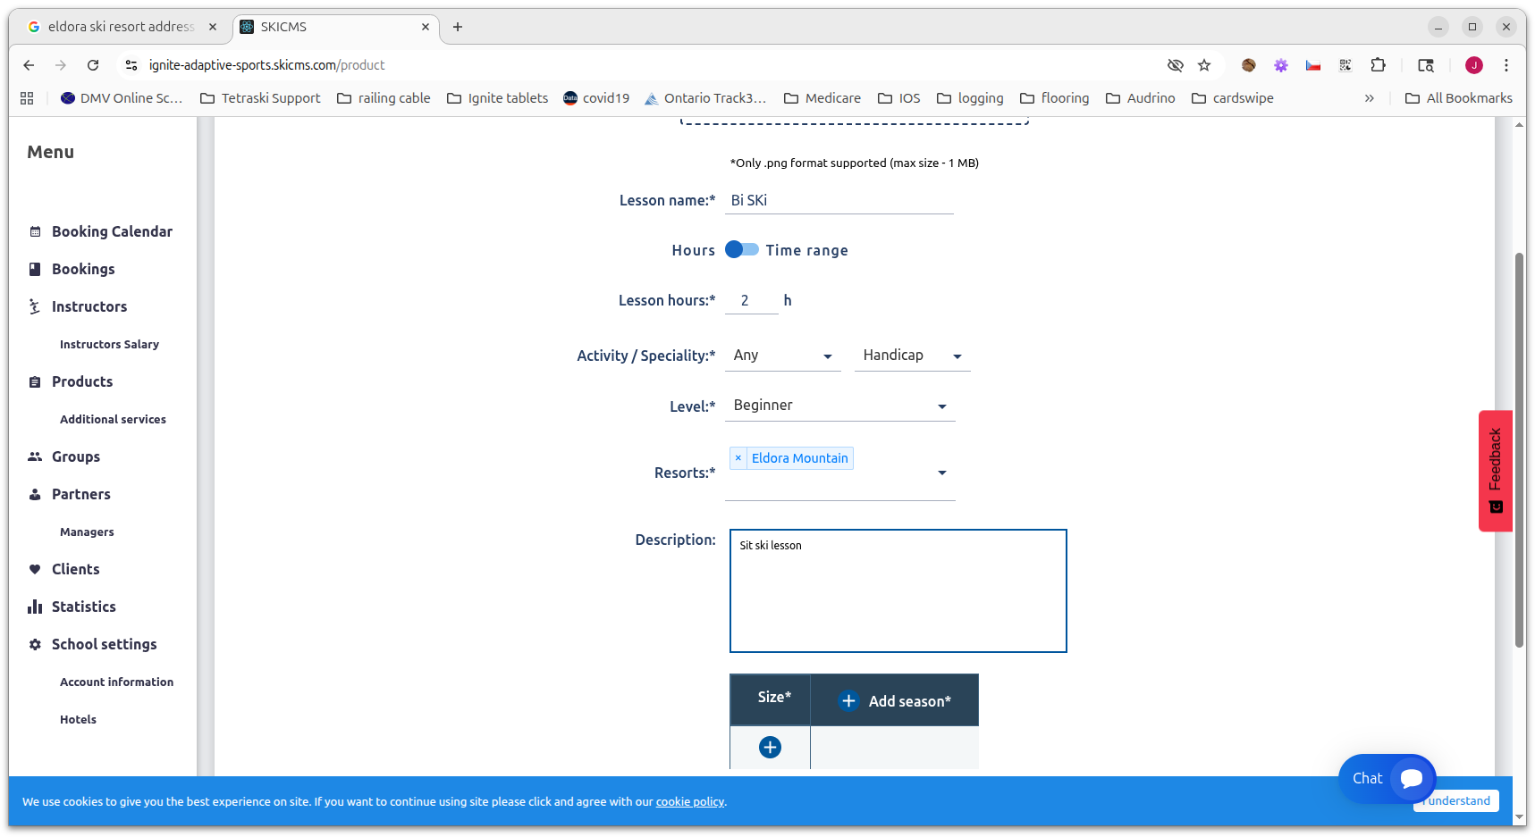

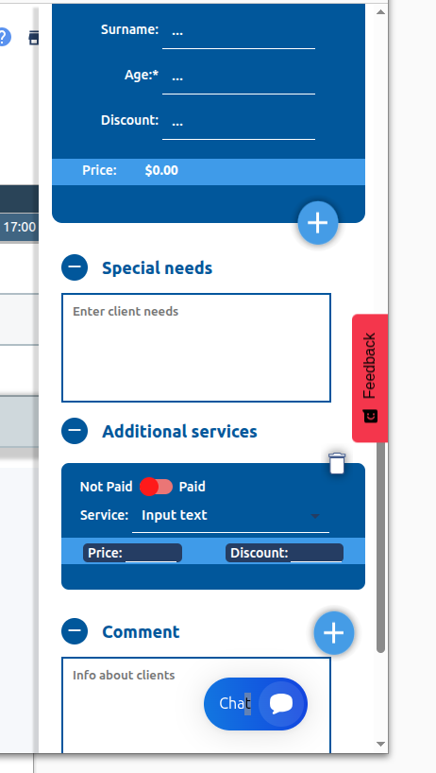
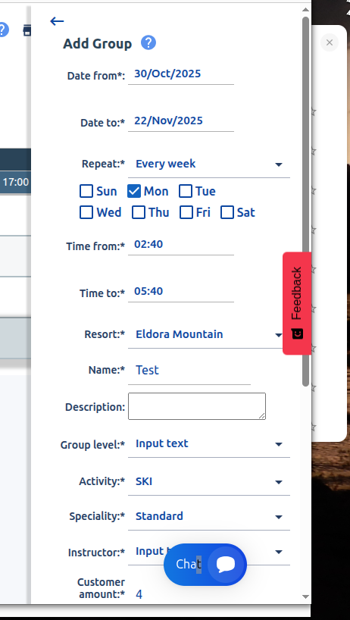
Create a group Create students

Instructor Profile.

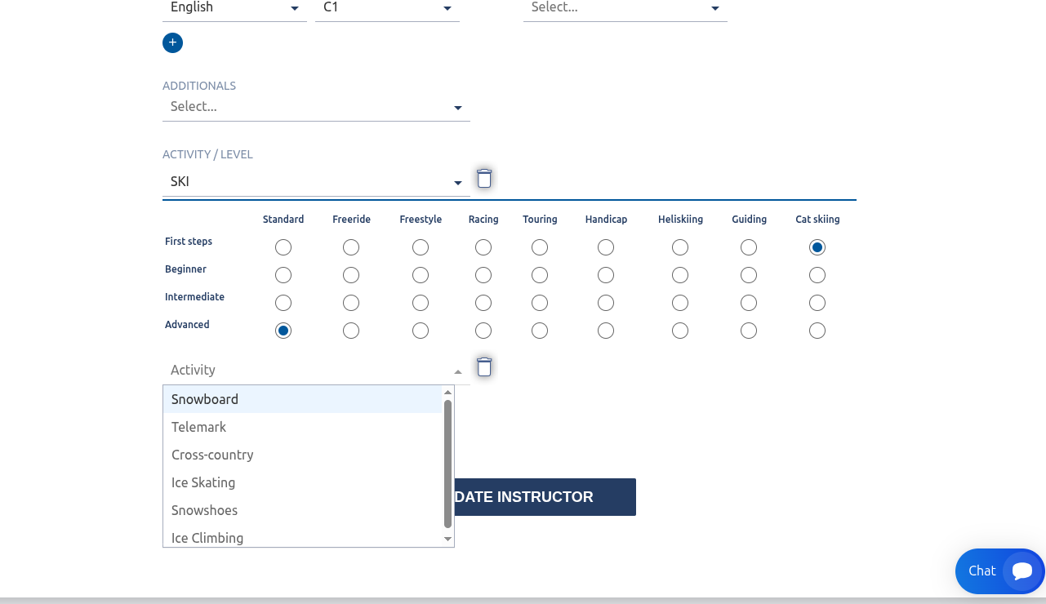

flaik.com

Training I did not see a way to create instr qualifications
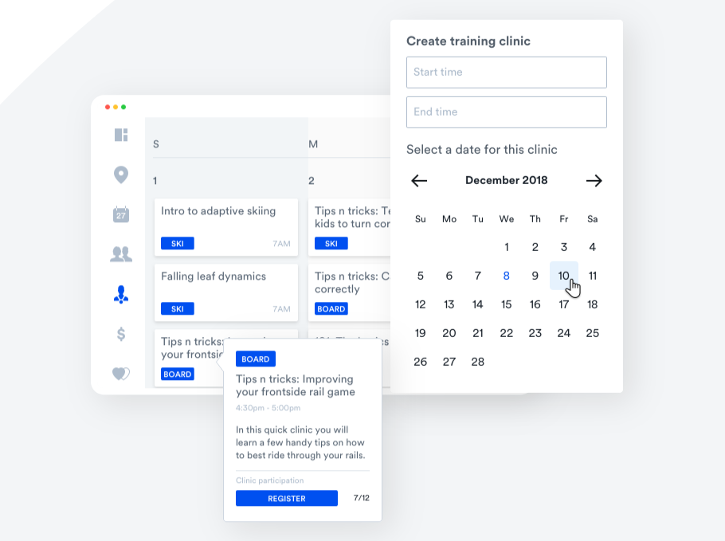

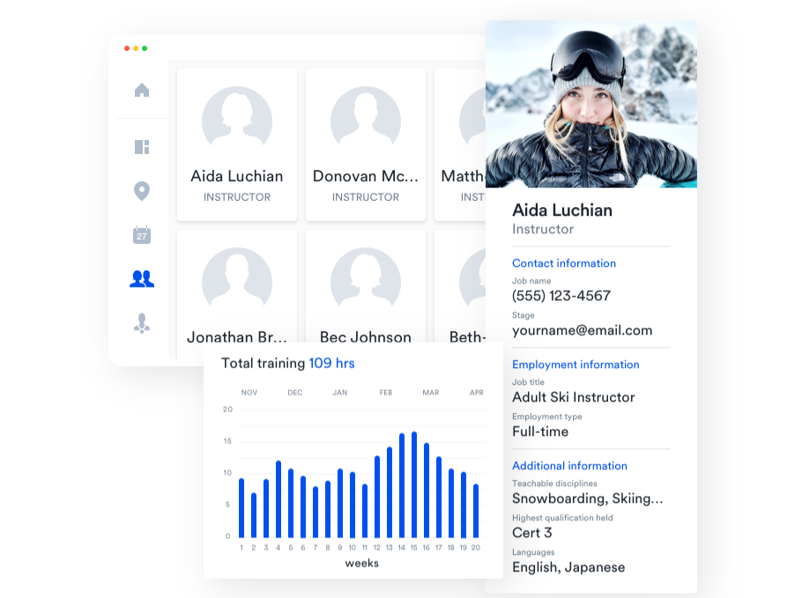
Instructor Profile -

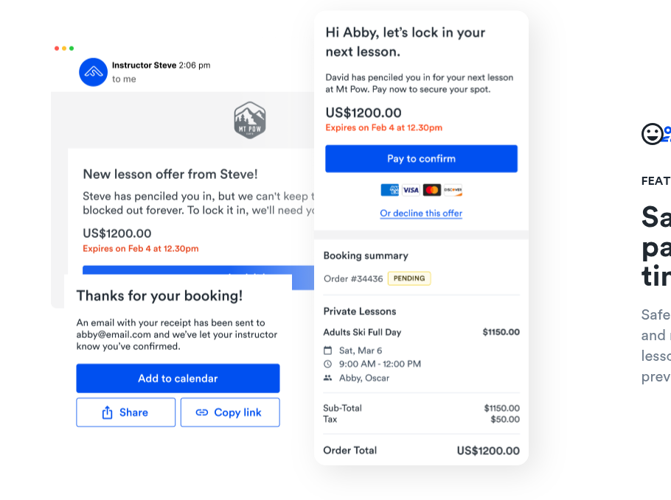
Booking - did not see a way to request and not have to pay.

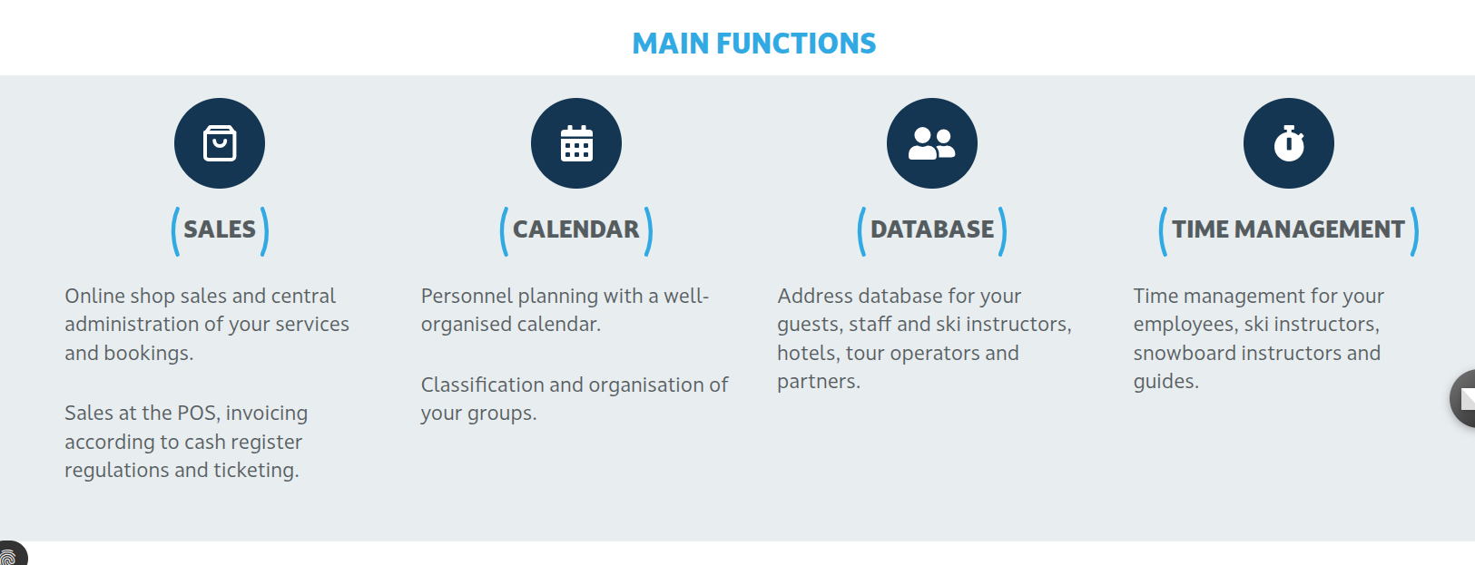
Waldhart
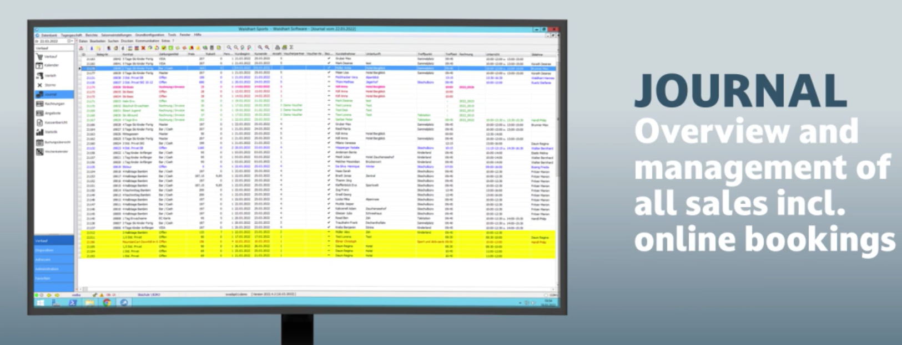
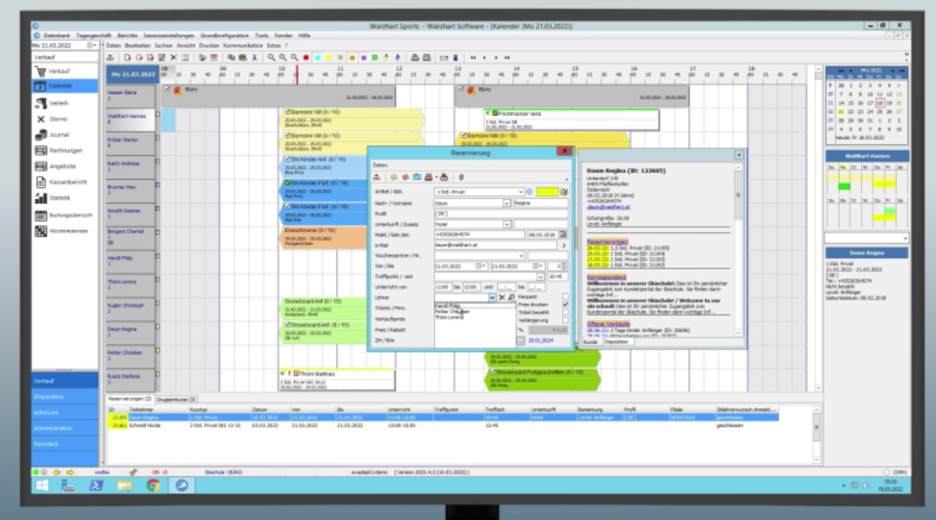

Only Sky
Only other one to mention Adaptive Lessons

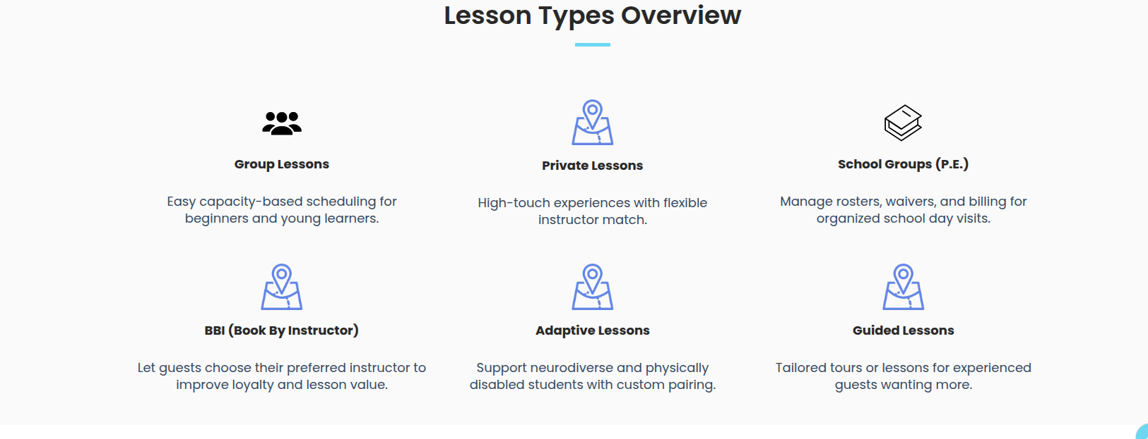

AccountsX Home Page of Super User - Many of these Items are available to regular staff.​

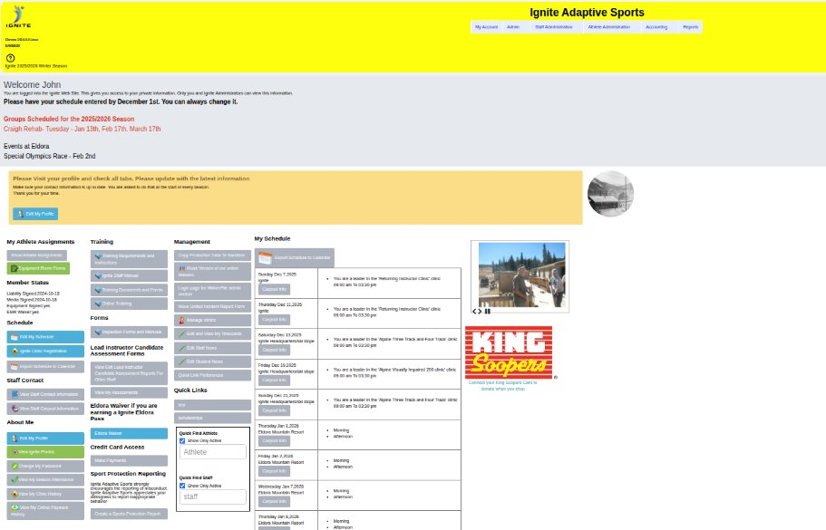

AccountsX

Hover on student or staff and get a quick info.
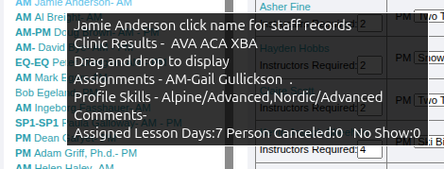

Click on student from any page and get these options. Similar for staff.


Fully customizable student progress reports - what is very useful is the type of equipment. Once settled on the equipment used (water sports in this instance) is recorded in the students equipment preference in the scheduling pages. The next time they come the supervisor/scheduler will see that equipment and take appropriate actions.
