LOC Social Media Recommendations
Content Types:
- Static images
Examples:
  - Highlights from competitions, athlete photos, gifting moments, etc.
  - Graphics with information about the chapter ex: incorporating WOW factors into a carousel image to learn more about the LOC’s
- REELS & Stories (Short form video): different concepts/ideas to highlight the LOC
  - Story posts: Offer a more causal real-time way to engage with your audience (leveraging interactive tools like polls/questions/etc), share quick updates, and content in real time, showcase new posts to drive more traffic – helps to increase your reach and build stronger connection to your followers.
  - Reels / Short Form Video: Offer significantly higher visibility and reach compared to traditional statics, perfect placement to attract new followers, increase discoverability, boost engagement, and expand brand awareness – perfect for expanding reach, brand building, trend engagement, and offering creative flexibility in key message delivery.
Examples:
  - Asking participants to talk about their experiences with the LOC’s - fosters engagement in the community – not only interacting in person at events for capture but then also online once posted – to see themselves/support those they know/recognize
  - Interviewing participants after gifting moments to hear how this will impact their experience
  - Interviewing different members of these LOC’s/Move United staff to have them talk about WOW factors of the organization
  - Example SFV
Collaborative Post Considerations & Instructions (Only relevant to Meta)
Considerations for which account is the primary creator:
- The person who created the post is the primary creator and sends the invite to the collaborator. You can add multiple collaborators to your post (up to 5).
- If the original creator switches their account to private, only their followers can see the post.
- Only the original creator can delete the post. If they do, it will be removed from the collaborator's profile as well.
- The original creator maintains the post. If the original creator deactivates their account, the post no longer exists. It will be removed from the collaborator's profile as well. However, if the original creator reactivates their account, the post will be restored on both the original creator's and the collaborator's profiles.
- The post will share the same copy/caption on both pages – both accounts will be able to author the post, but it will appear the same on both accounts.

How to Invite a Collaborator:
1. Before you publish your post, tap Tag people.
2. Tap Invite collaborator.
3. Search for the account you want to add as a collaborator, then tap the account.
4. Tap Done.
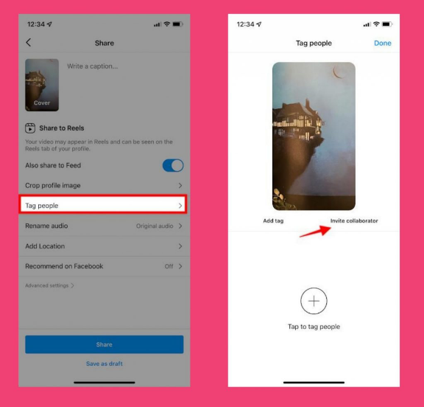

How to Accept a Collaboration Request:
- You'll receive a message when you're invited to collaborate on a post. To accept the invite to collaborate on a post:
1. Tap the airplane icon or messenger icon in the top right of Feed.
2. Tap the conversation from your Chats list where you've received the invite.
3. Tap the collaboration invite.
4. Tap Review.
5. Tap Accept
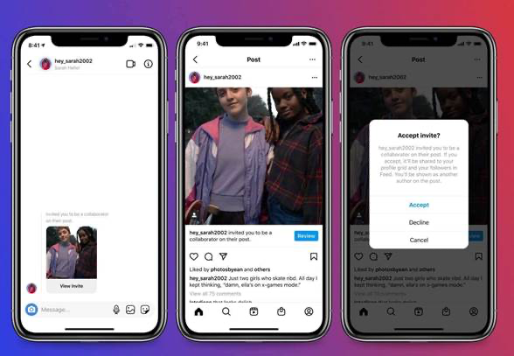

Ways to Expand Reach:
- Collaboration with Team Hartford athletes will be led and coordinated by The Hartford.
- LOC-owned opportunities: LOCs are encouraged to ask their own athletes, local partners, and relevant organizations if they are willing to participate in collaborator posts. These collaborations help expand reach by exposing posts to both the LOC’s followers and the collaborators audience.
  - How to add collaborators on Instagram:
    - When building a post – after adding in your copy, click tag people, and there should be an option for ‘Invite Collaborators’
    - From there you can add up to 20 accounts to collaborate with
    - We recommend letting the person/company you want to collaborate with know before you send the invite so they can look out for it.
    - The account needs to accept the collaboration once you post the content
- Ask Team Hartford athletes/ LOC athletes to share on their channels
  - Once a post is live from the LOC – anyone can share that post on their personal accounts (Instagram – story, Facebook – feed). This will encourage followers of these accounts to see the post that the LOC has shared and interact
- Utilizing hashtags
  - By utilizing hashtags in the content created - Utilizing hashtags can help more people see your post by making it discoverable to a wider audience beyond your followers and boost engagement.
  - Recommended hashtags include: #AdaptiveSports #MoveUnited #AdaptiveAthletes #DisabilitySports #InclusiveSports #WheelchairBasketball (hashtags specific to the sports featured)
  - How to Identify Hashtags & Keywords:
    - Leverage the landing page or URL you want users to ultimately go to and identify keywords from that page (even leverage them from Keyword search campaigns if you have them)
    - Identifying successful creators in the category you want to be in
      - EX: I will regularly check in on the content of Adaptive Athletes with strong social communities and leverage hashtags they use (could be equipment creators, event spokespeople, etc. - anyone who has ‘influence’/community within your niche
    - Use the search function on the popular page and start searching for content like your own:
      - What search terms auto-populate in the search bar?
      - What verbiage are they using on their content?

Copy Best Practices
- Copy is important because it can elaborate on the story from the content that is shared. There are a couple ways to make copy more compelling:
  - Having a strong and creative opening
  - Telling a story / including key points
  - Including a Call to Action
  - All content doesn’t need to ‘exist’ in the photo/video assets
  - Using the same process of identifying hashtags, you can identify keywords to incorporate into captions to increase searchability and interest targeting for the algorithm
  - Fit in more of a story in the post copy
    - EX: We’re bundling up to hit the slopes with @MoveUnitedSport at The Hartford’s Ski Spectacular 🧣🏂 ⛷️ Increasing access to adaptive sports and equipment remains a core focus for us at The Hartford. Learn more: The Hartford Ski Spectacular - Move United % #SkiSpec #HumanAchievement
    - EX using WOW Factors to promote (using Texas Parasport):
🏅 Welcome to the Texas Parasport Games! 🏅

In partnership with @TheHartford, this @MoveUnited sanctioned event in San Antonio welcomes 250-300 athletes with physical and visual disabilities to compete in nine sports. Held at Morgan’s Wonderland and nearby facilities, it offers top-tier competition and training. Learn more about everything Texas Parasport Games has to offer: Texas Parasport Games #TexasParasportGames #MoveUnited #AdaptiveSports #InclusiveSports #TheHartford

Posting Cadence
- When promoting events like this – it is important to keep up a regular posting cadence if the goal is promoting registration. If you are looking to post more regarding awareness of the event, posts can be less frequent since there is no CTA that you need the audience to take.

Instagram Algorithm Insights
Instagram’s algorithm determines what content users see based on multiple ranking signals. Here’s a quick breakdown of how it works across different content types:
1. Feed & Stories Algorithm
• Interactions: Prioritizes posts from accounts you engage with (likes, comments, shares, DMs).
• Relevancy: Evaluates content based on past behavior (e.g., if you engage with workout videos, you’ll see more).
• Timeliness: Newer posts are favored, but engagement matters.
• Relationships: Content from close friends, family, and frequently messaged accounts gets boosted.
2. Explore Page Algorithm
• Interest Matching: Surfaces content similar to what you’ve engaged with in the past.
• Engagement Signals: High-performing posts with strong engagement get recommended.
• Account Behavior: Looks at which profiles you interact with and suggests similar ones.
3. Reels Algorithm
• Watch Time: Prioritizes videos users watch fully or rewatch.
• Engagement: Likes, shares, saves, and comments boost visibility.
• Originality: Original, non-reposted content performs better.
• Trends & Audio: Reels using trending sounds and effects get more reach.
4. Shadow-banning & Demotions
• Low-quality, recycled, or engagement-bait content may be demoted.
• Content against guidelines (misinformation, sensitive topics, misleading captions) can get hidden.
Best Performance Practices Based on Algorithm:
• Post consistently and at optimal times.
• Encourage interaction (polls, questions, and calls to action).
• Use a mix of trending and niche hashtags.
• Prioritize short-form video content (Reels).

Social Media Design and Creative Best Practices
Foundations
Universal Creative Principles:
- Design mobile-first: assume phone viewing and sound-off.
- One clear message per post (one moment, one lesson, one takeaway).
- Use vertical formats when possible. More screen space = more attention.
- Consistent visual identity: 2–3 colors, 1–2 fonts, repeatable style.
- Always include a simple CTA (question, save prompt, or ‘follow for…’).
Composition & readability
- Make the subject big in frame (faces, hands, gear, action).
- Use strong visual hierarchy: big headline → supporting line → details.
- Keep text minimal; use short phrases, not paragraphs.
- Avoid visual “clutter” near edges; leave breathing room.
- Show adaptive equipment when it’s part of the story (authenticity + education).
Accessibility checklist (make content for everyone)
- Add alt text to informational images.
- Caption every video and check auto-captions for accuracy.
- Use CamelCase hashtags (e.g., #WheelchairBasketball).
- Keep color contrast high.
- Limit excessive emojis, as screen readers read each one.
- Avoid flashing content.
Build your personal brand kit
- Pick a consistent ‘look’: color palette + fonts + photo/video style.
- Choose 3 content pillars (e.g., Train • Compete • Teach/Advocate).
- Create repeatable templates: Reels cover, carousel cover, quote graphic.
- Use the same handle/photo across platforms for recognition.
- Batch content: capture multiple clips during one practice or event, so that you can create multiple pieces of content from it.

Sizing and Formats
Quick sizing cheat sheet (most-used formats)
- Vertical video (Reels/TikTok/Shorts): 1080×1920 (9:16)
- Instagram feed: 1080×1350 (4:5) or 1080×1080 (1:1)
- Facebook Reels/Stories: 1080×1920 (9:16)
- YouTube Shorts: 1080×1920 (9:16)
- LinkedIn: 1200×627 (landscape) or 1200×1200 (square)
- X (Twitter): 1600×900 (16:9) or 1200×675 (16:9)
- Keep key text/logos within safe zones to avoid UI overlap
- Export for video: MP4 (H.264) recommended; add captions
Safe zones (don’t let the platform elements cover your text)
- Keep important text/logos away from the bottom (captions/CTAs) and the right side (buttons).
- Rule of thumb: keep key elements in the central 70–80% of the frame.
- Preview before posting: check how it looks in-feed and on your profile grid.
- If you use on-screen captions, place them higher than you think.
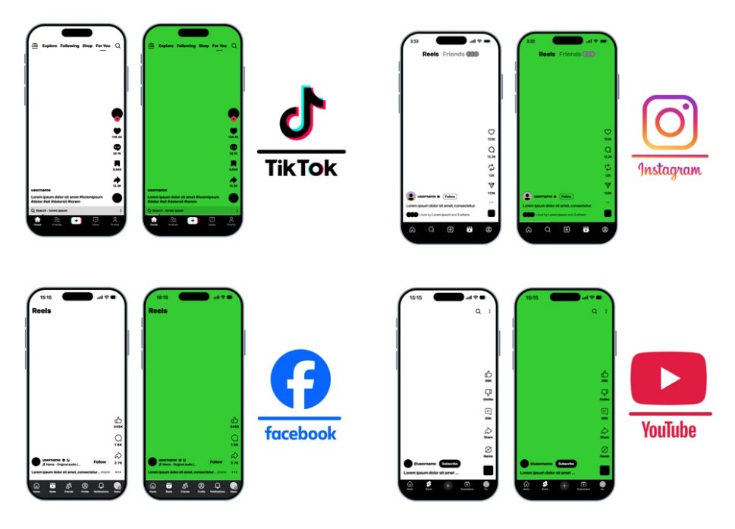
File formats + export settings (quick wins)
- Record and edit in 9:16 when possible (avoid heavy cropping later).
- Aim for 1080p (Full HD) to stay crisp after platform compression.
- Use burned-in captions or upload an SRT when the platform supports it.
- Keep text large and high-contrast for readability on phones.

Engagement “Playbook”
Short-form video that performs
- Hook in the first 1–3 seconds: start with action, result, or a bold question.
- Make it feel native: authentic clips often outperform overly polished edits.
- Use captions/text overlays for silent viewers.
- Edit for pace: remove dead time; make every second earn attention.
- End with a CTA: ‘Save this drill’, ‘Comment your goal’, ‘Follow for…’
Carousels + photo posts that get “saves”
- Use a cover slide with a promise (what the viewer will gain).
- One idea per slide; make it readable in 1–2 seconds.
- Add simple structure: 1) Hook 2) Steps 3) Proof 4) CTA.
- Template your slides so you can create faster and stay consistent.
Cross-platform engagement multipliers
- Show the process, not just the podium: training, rehab, prep, gear.
- Teach something small and specific (micro-tips earn saves and shares).
- Create a series: repeatable formats build audience habits.
- Collaborate: teammates, clubs, sponsors, creators = wider reach.
- Reply to comments quickly, as early engagement helps distribution.

