Risk Domains Model for Outdoor Programs
Source: Baierlein, Jeff A. Risk Management for Outdoor Programs: A Guide to Safety in Outdoor Education, Recreation and Adventure. Seattle, Washington, Viristar LLC, 2019.

Understanding the Risk Domains Model
Incidents in outdoor programs rarely result from a single cause. The Risk Domains Model illustrates how multiple factors across different organizational and environmental levels interact to create incidents. Understanding these domains helps identify prevention opportunities and develop comprehensive risk management strategies.
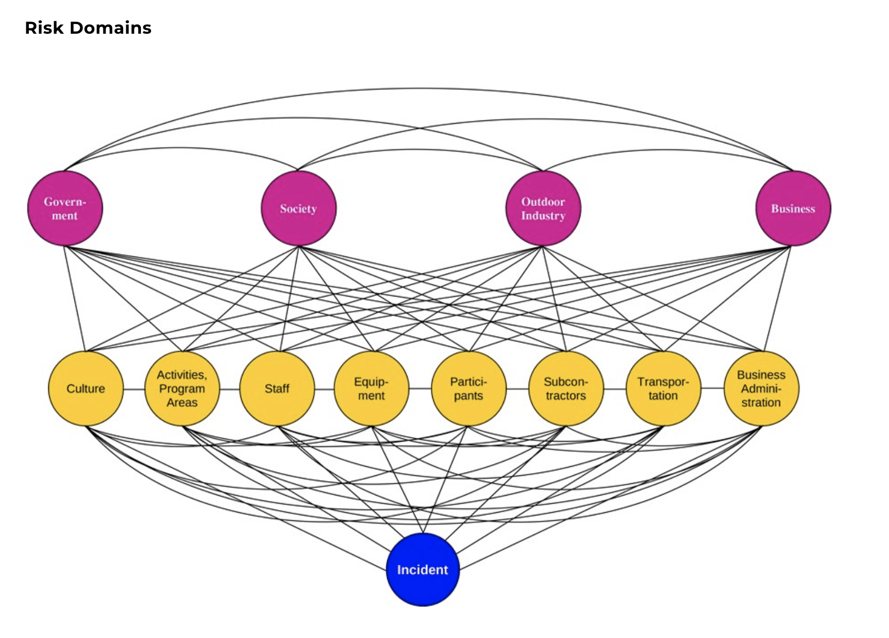

The Three Levels of Risk Domains

EXTERNAL INFLUENCES (Top Level)
Government
• Laws, regulations, and permits that govern outdoor programming
• Compliance requirements (ADA, Coast Guard, state boating laws)
• Legal frameworks affecting program operations
Society
• Cultural expectations and attitudes toward risk
• Litigation trends and public perception
• Community values and social norms
Outdoor Industry
• Professional standards and best practices
• Industry certifications and training requirements
• Emerging trends and innovations in outdoor recreation
Business
• Organizational structure and financial considerations
• Resource allocation and budget constraints
• Insurance requirements and business pressures

OPERATIONAL FACTORS (Middle Level)
Culture
• Organizational values and safety culture
• Communication patterns and decision-making norms
• Attitudes toward risk, disability, and inclusion
Activities/Program Areas
• Specific programming offered (kayaking, climbing, etc.)
• Complexity and risk profile of different activities
• Environmental conditions and settings (pool, lake, river)
Staff
• Training, certifications, and experience levels
• Judgment, decision-making, and technical skills
• Communication abilities and leadership qualities
Equipment
• Selection, appropriateness, and maintenance
• Adaptive equipment and modifications
• Inspection protocols and replacement schedules
Participants
• Physical, cognitive, and sensory abilities
• Experience levels and expectations
• Communication needs and behavioral considerations
Subcontractors
• Equipment vendors and maintenance providers
• Partner organizations and collaborators
• Third-party service providers
Transportation
• Vehicle safety and accessibility
• Equipment transport logistics
• Participant mobility considerations
Business Administration
• Policies, procedures, and documentation systems
• Intake processes and informed consent
• Emergency action plans and incident reporting
• Staff training protocols and quality assurance

OUTCOME (Bottom Level)
Incident
• The event that occurs when risk domains interact
• Can range from near-misses to serious accidents
• Provides learning opportunities for system improvement

Key Insights for Adaptive Kayaking Programs
• Interconnection: Notice how all operational domains (yellow) connect to incidents. Multiple factors typically interact to create an incident.
• Systems Thinking: This model moves beyond individual blame to understanding how organizational systems contribute to safety or risk.
• Prevention Opportunities: Each domain represents a place where you can intervene to prevent incidents.
• Adaptive Considerations: Adaptive programming adds complexity across multiple domains, particularly in Equipment, Participants, Staff, and Culture.

Notes & Reflections
Domains most relevant to my program:

Domains where we have gaps or weaknesses:

Connections I notice between domains:

Action items for my program:

Questions to explore further:

Visual Reference
Risk Domains Diagram:
EXTERNAL INFLUENCES (Pink/Magenta):
• Government | Society | Outdoor Industry | Business
↓
OPERATIONAL FACTORS (Yellow):
• Culture | Activities/Program Areas | Staff | Equipment
• Participants | Subcontractors | Transportation | Business Administration
↓
OUTCOME (Blue):
• Incident
All operational domains connect to and influence the potential for incidents.

Workshop: The Intersection of Risk Management Systems and Kayak Programming Date: April 18, 2026

